# Invoice Outsort – Age Check

### **Outsorting**

### Usage

Errors in documents from a simulation (for example, due to incorrect Customizing settings or inconsistent master and transaction data) are generally not discovered as often as errors in actual billings. During a billing simulation, neither an invoicing or outsorting checks for invoicing are carried out. For this reason, you must activate outsorting for billing, and create outsorting checks **for the billing** .

In mass simulation, the automatic outsorting checks for billing are executed during **periodic billing** . The checks from the standard check list are executed in the same way as in actual billing.

Note Note

In Customizing for *SAP Utilities* , you can use the following activities:

*  *Contract Billing*  *Billing Execution*  *Outsorting for Billing* 
*  *Tools*  *System Modifications*  *User-Defined Outsortings in Billing/Invoicing*  *Define Check List for Billing* 

The number of simulation documents that are outsorted is dependent on the choice of limit values against which you are making the checks. Use test runs to determine the appropriate limit values.

Note Note

You can use **statistics from simulation indexes** to quickly determine how many documents are outsorted after a simulation run. From the *SAP Easy Access* menu, choose  *Utilities Industry*  *Billing*  *Mass Simulation*  *Monitoring*  *Statistics for Simulation Indexes.*  .

#### Activities

##### Different Outsorting for Real Billing and Mass Simulation

You can define which checks belong to an outsorting check group in Customizing for *SAP Utilities* under  *Contract Billing*  *Billing Execution*  *Outsorting for Billing*  *Define Checks per Outsorting Check Group for Billing*  .

In the Meaning of Outsorting Checks for Billing field you can define the following outsorting checks with **limits that are close together** for **actual billing** and outsorting checks with **value limits that are not as close together** for **mass simulation**

# Outsorting

## Use

Using this component you can outsort billing documents or orders for bill printout from automatic processing. The outsorting process, which occurs after billing or invoicing, places the outsorted documents/orders on an exception list. The agent must check the documents/orders and either release them explicitly before invoicing or printing, or reverse them. An outsorting group is defined in the contract or in the contract account, behind which you can store special validation checks. If the conditions of the checks are fulfilled, the document is outsorted in billing or in invoicing.

The following graphic shows the outsorting process:

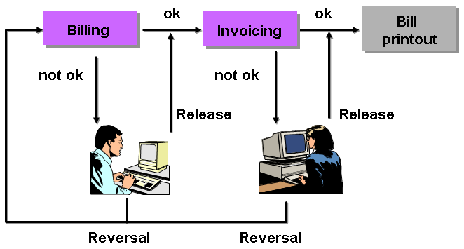

## Features

You can outsort billing documents on the basis of the following validations:

* Absolute amount by which the net amount of the bill is exceeded or falls below
* Percentage that the budget billing amount deviates from the net amount of the bill
* Absolute amount that the budget billing amount deviates from the net amount of the bill
* Bills with a balance of zero
* Estimated meter readings
* User-defined validations

You can outsort print orders on the basis of the following validations:

* Absolute amount by which the gross amount of the bill is exceeded or falls below
* Absolute amount by which the bill sum total is exceeded or falls below
* Absolute amount by which the difference amount is exceeded (in the case of a payment plan)
* User-defined validations